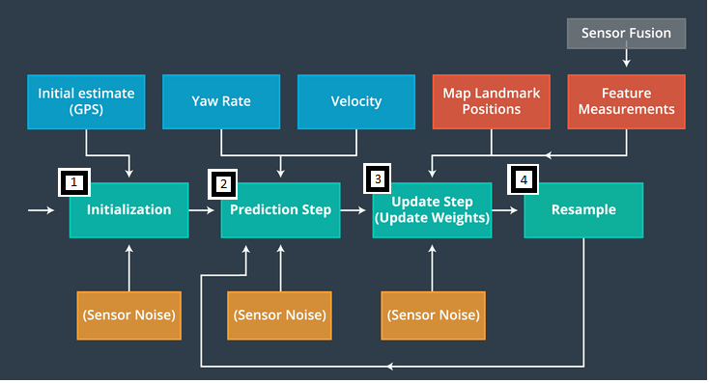

1. Initialization

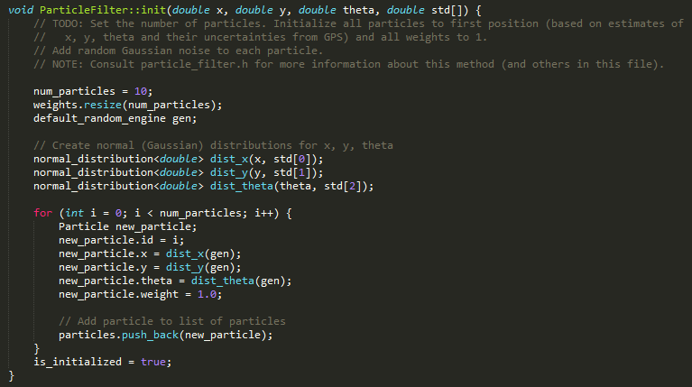

1. Prediction Step

Adding measurement & Gaussian noise to each particle.

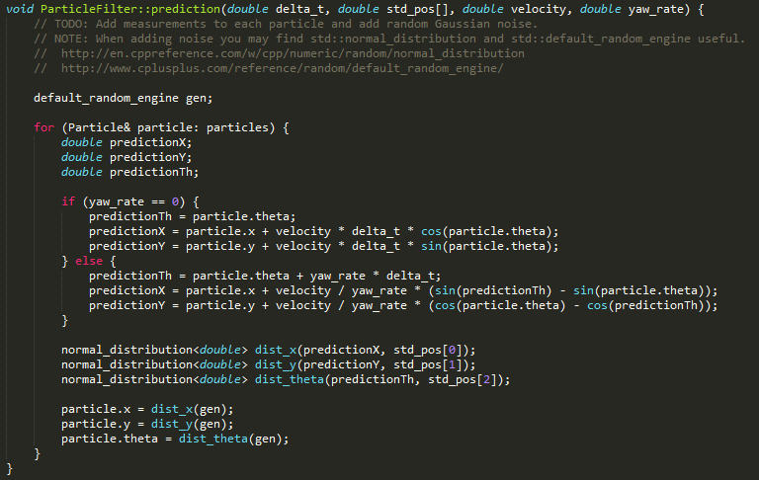

1. Update Step
   1. Initialize wait



* 1. Transformation of “particle” against each observation (obj)



* 1. Closest landmark from “Transformed of particle”

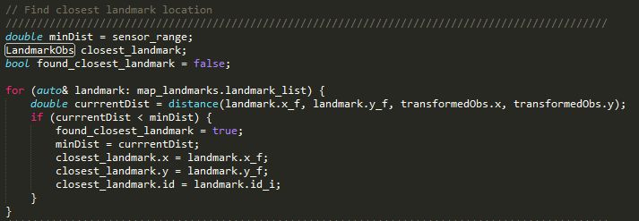

* 1. Calculate particles final weight if the observed landmark has in range of sensor

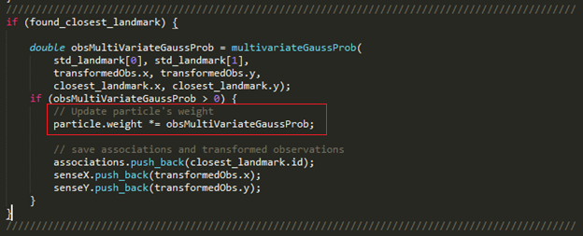

1. Resample

